**ELECTRONIC DIE**

# PROJECT DESCRIPTION

Electronic dice consists of seven LEDs and two buttons. One button is a test button which turns on all the seven LEDs and when the button is released then all LEDs are switched off. The second button is Acknowledge button which when pressed and released randomly displays a number between 1 and 6. This is accomplished making the dice run in the states 1-6 in circle at very high frequency by pressing the acknowledge button. Number is displayed until user operates dice again or if test button is pressed.

## INPUT SIGNALS

Two buttons:

* TST - Test button
* ACK - Acknowledge button

## OUTPUT SIGNALS

Seven LEDs:

|  |  |  |
| --- | --- | --- |
| L1 |  | L5 |
| L2 | L4 | L6 |
| L3 |  | L7 |

* L1
* L2
* L3
* L4
* L5
* L6
* L7

## STATES

Eight states:

* in - initial state
* 7 - all LEDs on
* 1 - only L4 is on (one LED is on that is the number shown is 1)
* 2 - L1 and L7 are on (Total two LEDs are on that is the number shown is 2)
* 3 - L1, L4 and L7 are on (Total three LEDs are on that is the number shown is 3)
* 4 - L1, L3, L5 and L7 are on (Total four LEDs are on that is the number shown is 4)
* 5 - L1, L3, L4, L5 and L7 are on (Total five LEDs are on that is the number shown is 5)
* 6 - L1, L2, L3, L5, L6 and L7 are on (Total six LEDs are on that is the number shown is 6)

## INPUT EQUATIONS

$$in=in∙\overline{TST}∙\overline{ACK}+7∙\overline{TST}+(1+2+3+4+5+6)∙TST$$

$$7=in∙TST+7∙TST$$

$$1=6∙\overline{TST}∙ACK+1∙\overline{TST}∙\overline{ACK}+in∙\overline{TST}∙ACK$$

$$2=1∙\overline{TST}∙ACK+2∙\overline{TST}∙\overline{ACK}$$

$3=2∙\overline{TST}∙ACK+3∙\overline{TST}∙\overline{ACK}$

$$4=3∙\overline{TST}∙ACK+4∙\overline{TST}∙\overline{ACK}$$

$$5=4∙\overline{TST}∙ACK+5∙\overline{TST}∙\overline{ACK}$$

$$6=5∙\overline{TST}∙ACK+6∙\overline{TST}∙\overline{ACK}$$

## OUTPUT EQUATIONS

$$L1=2+3+4+5+6+7$$

$$L2=6+7$$

$$L3=4+5+6+7$$

$$L4=1+3+5+7$$

$$L5=4+5+6+7$$

$$L6=6+7$$

$$L7=2+3+4+5+6+7$$

## ASM CHART

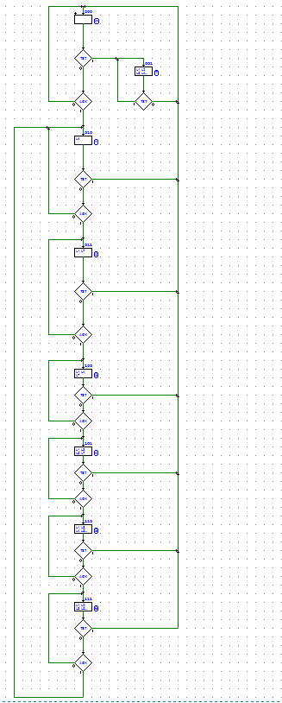

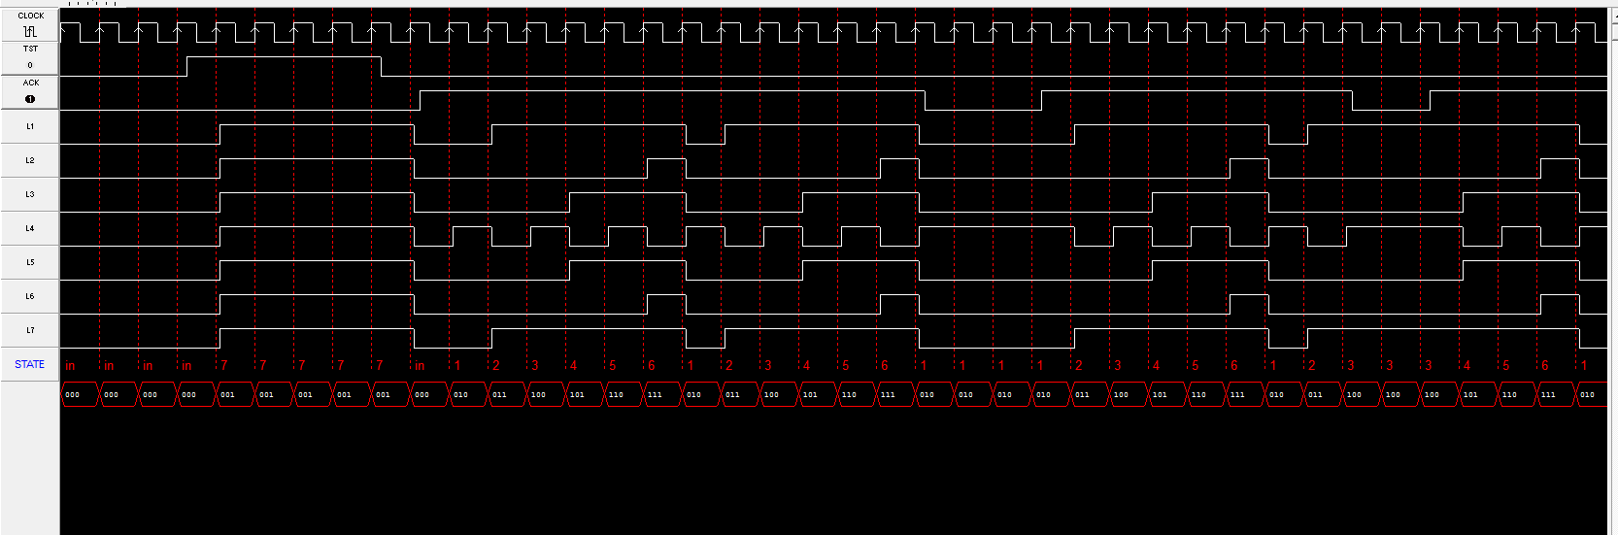ASM SIMULATION

## CIRCUIT

